**101891 – ICS 4B**

**Lab 2**

Lab 1 link: <https://github.com/fionachristina/101891_CCProjects>

**Output of the scanner description**

Lexical Analysis is the first phase of the compiler also known as a scanner. It converts the High-level input program into a sequence of **Tokens**.

**Input = hello, how are you? why is 77 + 33 ! = 100?**

Based on the input above, the below tokens are generated as the output.

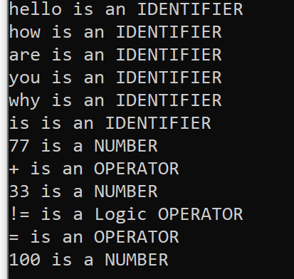

These tokens are generated using a regex. The regex identifies the identifiers, numbers and operators (math and logic). Blank spaces, new lines and removed.

The regular expressions I used:

1. [0-9]+ , for numbers
2. [a-z]+ , for identifiers
3. \\*|\\+|\\= |\\-|\\/ , for operators
4. \\!=|\\<, for logic operators